

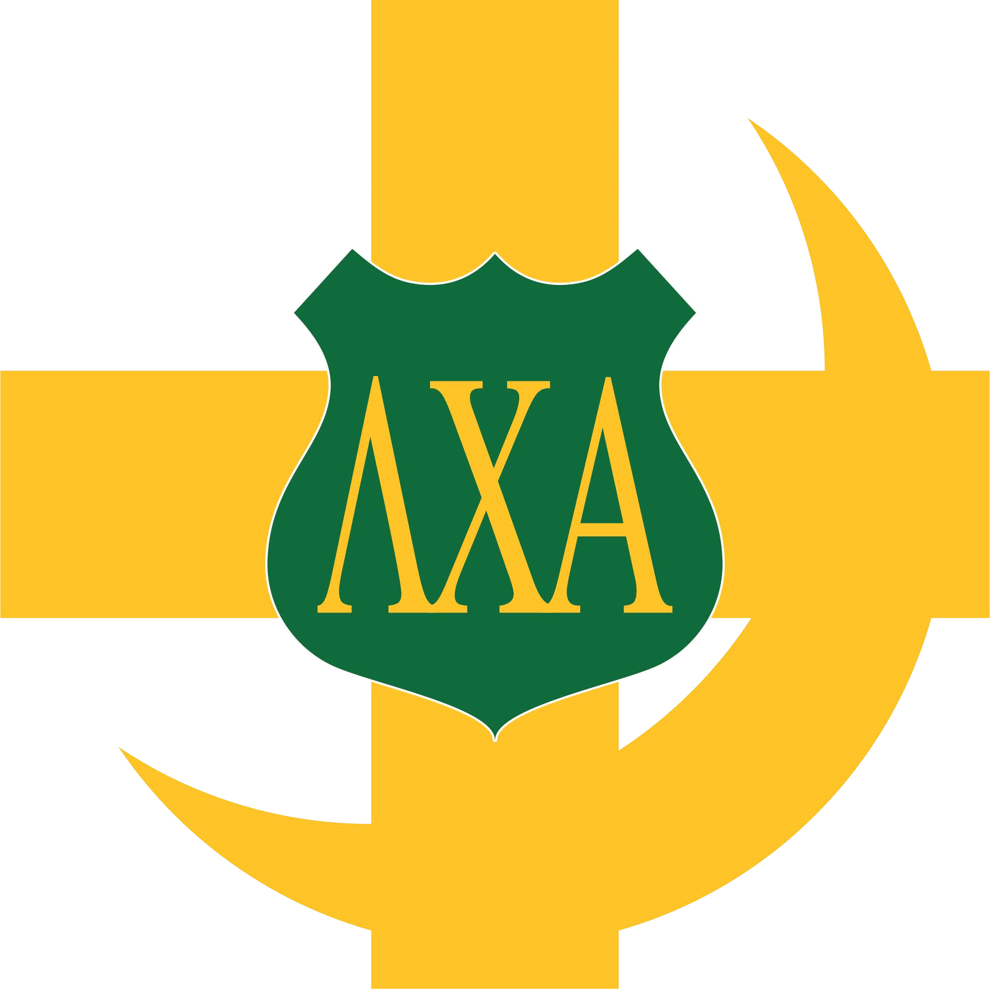
Awards
MS&T Inter
f
raternity Council 2023 Awards
•
Outstanding Chapter President
•
Philantrophy Outreach
•
Scholastic Programing
Lambda Chi Alpha International Awards
2023
Scholastic Programming
-
Recognizes Chapters that have developed an
outstanding program resulting in superior academic achievement of its members.
2023 1
st Place Lambda Chi Academy Engagement
– A professional
development resources, functional training, and relevant aspects of the fraternity experience
into marketable skills.
2018
Public Af
fairs Program
ing

-
Recognizes Chapters with the most

outstanding programs of community service and philanthropic activities.
Two Grand High Alpha Awards
-
Recognizes Chapters that have maintained a
superior level of operations for at least three consecutive years. A chapter may not earn the
Grand High Alpha again until at least three years have elapsed since previously winning
award.
Three Order Of Merit -
Since 1935 the Fraternity has recognized members
who
have

provided
unusual, lengthy, and dedicated service
to the Fraternity at the chapter level.
One Order Of Achievement
-
Presented to those brothers of Lambda Chi Alpha
who have distinguished themselves by outstanding accomplishment in their chosen field and
serve as a role model through their success and have thereby brought honor and respect to
our great Fraternity.

